**Unit 01**

**Short Questions**

* Define machine learning?
* What are the types of machine learning?
* List out any 5 application of machine learning?
* What do you mean by hypothesis space, instance space, version space?
* Explain list then eliminate algorithm?
* List the Perspectives and issues in machine learning?
* Write remarks on version spaces and candidate elimination?
* Write the concept of inductive bias in candidate elimination?
* Discuss the necessary measure required to select the attributes for building a decision tree using ID3 algorithm?
* Write appropriate Problems for Decision Tree Learning?
* What is Inductive Bias In Decision Tree learning

**Long Questions**

* What is Well-posed learning problem? Explain with examples?
* Define machine learning? Describe steps in designing a learning system?
* What do you understand about a concept learning task? Explain with an example?
* Write about find-S: finding a maximally specific hypothesis algorithm?
* Explain in detail Candidate Elimination Learning algorithm with an illustrative example.
* Explain the concept of Decision Tree Learning? Construct a Decision Tree using ID3 by considering the following Training Examples:

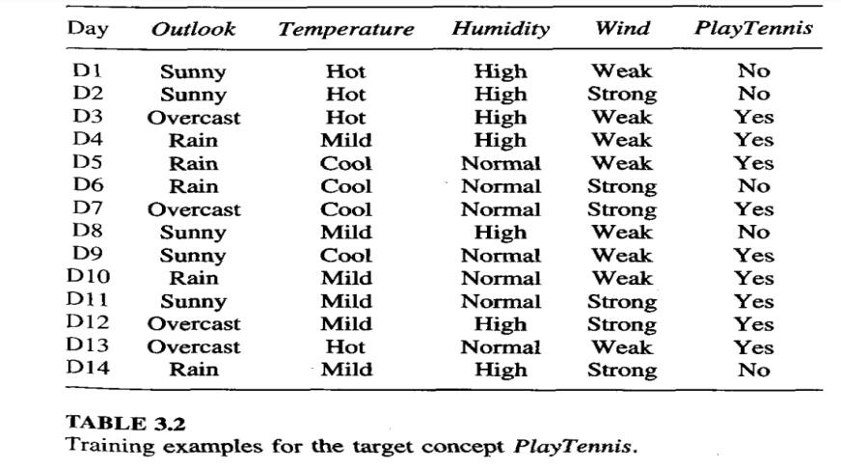

* Explain the concept of Decision Tree Learning? Construct a Decision Tree using ID3 by considering the following Training Examples:

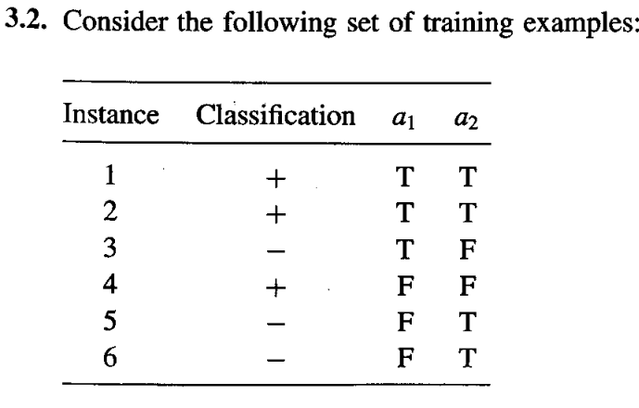

* Explain the issues in Decision Tree and how to handle them?

**Unit 02**

**Short Questions**

* Define Perceptron?
* What is gradient descent and delta rule?
* Why stochastic approximation to gradient descent is needed?
* Explain in brief representation power of feed forward network?
* List the appropriate problems for neural network learning?
* Discuss the two approaches to prevent over fitting the data?
* Give the differences between the hypothesis space search in ID3 and Candidate elimination algorithm?
* Define Sample error, True Error mean, variance, standard deviation and confidence interval?
* How to compute expected value and variance of a random variable?

**Long Questions**

* Define Perceptron? Draw neat diagram and explain the concept of single perceptron with notation.
* Discuss the perceptron training rule and Delta rule?
* Write and Explain Back Propogation algorithm?
* Explain the remarks of Back propagation algorithm?
* Explain maximum a posteriori (MAP) hypothesis using Bayes theorem?
* Explain the methods for comparing the accuracy of two hypotheses?

**Unit 03**

**Short Questions**

* Define expected value, variance and standard deviation?
* State Bayes theorem?
* Explain sample error and true error?
* What us confidence interval?
* What is instance based learning?
* Mention the features of Bayesian learning?

**Long Questions**

* Discuss the relationship between the maximum likelihood hypothesis and the least squared error hypothesis.
* Explain Naïve Bayes classifier?
* Explain EM algorithm?
* Explain K-nearest neighbor learning algorithm?
* Explain brute force MAP Algorithm?
* Discuss minimum description length principal in brief?
* Explain locally weighted linear regression?
* Explain case based reasoning with example?

**Unit 04**

**Short Questions**

* How Genetic algorithm related to Darwinian Natural Selection?
* List the factors motivated the popularity of genetic algorithms
* Explain terms related to Genetic Algorithm? (Population, chromosomes, Gene, Fitness)
* What is difference between mutation and cross-over?
* Compare Single-Point and Two-Point cross over?
* What are stopping condition in Genetic Algorithm?
* What is sequential covering algorithm?
* What is Reinforcement Learning?
* What is Q Learning?

**Long Questions**

* Create or generate new offspring from the given population for genetic algorithm? Illustrate.
* Write the genetic Algorithm?
* Illustrate general-to-specific beam search algorithm for Learn-One-Rule?
* Illustrate the basic FOIL algorithm?
* Demonstrate Q-learning algorithm with an example?
* Illustrate to handle nondeterministic MDPs (Markov Decision Process)?

**Unit 05**

**Short Questions**

* Describe Analytical Learning?
* Define the weakest preimage of a conclusion?
* Define approximate inductive bias of PROLOG-EBG?
* Explain the FOCL algorithm?
* Compare and contrast purely analytical and purely inductive Learning?

**Long Questions**

* List the main properties of PROLOG-EBG algorithm? Is it deductive or inductive? Justify your answer.
* Illustrate Inductive-Analytical approaches to learning?
* Demonstrate the EBNN algorithm